**HOW TO CAPTURE LEADS AT <Insert event name>**

Scanning information for:

**<Merge Exhibitor Name>**

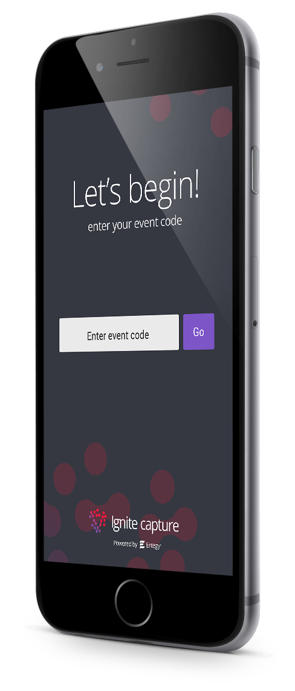

|  |  |
| --- | --- |
| **1. Download Ignite Capture**  Get it for iOS or Android at  [igniteevents.com.au](https://igniteevents.com.au/leadcapture)/leadcapture  *Important: Please ‘allow’ camera access when prompted to enable QR scanning* |  |
| **2. Access your event**  Using event code **<Insert event code>** |
| **3. Login**  Using your exhibitor code **EX** **<Merge Exhibitor Team Code>** and complete the signup form |
| **4. Scan Attendee Badges**  Tap to scan, hold badge 20cm from camera with the QR in the centre screen. A green tick indicates a successful scan. |
| **5. Manage and Export Leads**  Tap the ‘Leads’ button then on a profile to take notes and answer qualifying questions.  The ‘Export’ button emails a CSV of all captured data to yourself. |

**FAQS**Can’t login? Are you selecting the right login option?

|  |  |
| --- | --- |
| **Exhibitor Code**  This code is shared between all staff scanning at your exhibitor booth. After entering this, you will be prompted to fill in a signup form to create your scanning profile. | **Personal Login Credentials**  This combination of details is unique to you and cannot be shared between booth staff. Entering these details allows you to log straight into your scanning profile in the app. |

What are Qualifying Questions and how can I use them?

The Qualifying Questions feature is an in-app form for collecting additional data from your leads. You can create custom qualifying question in the app to be shared amongst your team.

To create custom qualifying questions in Capture app

1. Click **Manage** on the home screen
2. Select **Qualifying Questions** from the list of options
3. Click **+** to add a new question
4. Select the type of question you wish to add to your form
5. Add the **Question** and, if applicable, the response/s
6. Click **Save**