HOW TO CAPTURE LEADS AT <Insert event name>

<Merge Attendee First Name> <Merge Attendee Last Name>’s Scanning information for:
<Merge Organisation/Exhibitor>
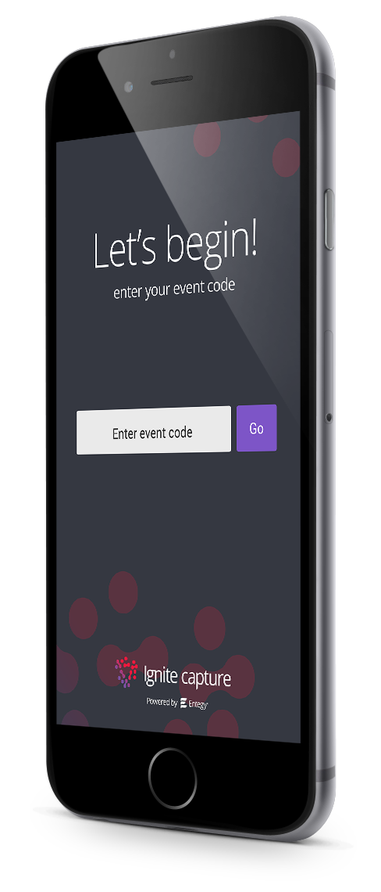
1. Download Ignite Capture
Get it for iOS or Android at
igniteevents.com.au/leadcapture
Important: Please ‘allow’ camera access when prompted to enable QR scanning

2. Access your event
Using event code <Insert event code>

3. Login
Using your app login credentials
Username: <Merge Attendee Username>
Password: <Merge Attendee Password>

4. Scan Attendee Badges
Tap to scan, hold badge 20cm from camera with the QR in the centre screen. A green tick indicates a successful scan.

5. Manage and Export Leads
Tap the ‘Leads’ button then on a profile to take notes and answer qualifying questions.

The ‘Export’ button emails a CSV of all captured data to yourself.
FAQS
Can’t login? Are you selecting the right login option?

Exhibitor Code  This code is shared between all staff scanning at your exhibitor booth. After entering this, you will be prompted to fill in a signup form to create your scanning profile. | Personal Login Credentials  This combination of details is unique to you and cannot be shared between booth staff. Entering these details allows you to log straight into your scanning profile in the app.

How do I log back into the Capture app?

If you log out of the App you will need to log back in with a personal Access Code
Step 1:  Select ‘Already have an account? Log in’ | Step 2 (if required):  Select ‘Recover my account details’

What are Qualifying Questions and how can I use them?

The Qualifying Questions feature is an in-app form for collecting additional data from your leads. You can create custom qualifying question in the app to be shared amongst your team.

To create custom qualifying questions in Capture app
- Click Manage on the home screen
- Select Qualifying Questions from the list of options
- Click + to add a new question
- Select the type of question you wish to add to your form
- Add the Question and, if applicable, the response/s
- Click Save

How do I add new people to my team?

Before you can add a team member to your team, they will need to be registered for the event with the event organiser.

To add team members in Capture app
- Click Manage on the home screen
- Select Manage Exhibitor Team and click +
- Accept the conditions
- Select an option
  - Click Add by Scan
    - Scan the QR code of the team member you wish to add
  - Click Add by Email
    - Enter the email address of the team member you wish to add (this will need to be the email address associated with their event registration)
- Team member will receive their team invite when they login to Capture app with their personal access code.

